***Function Type 4:***

Q)Convert Ferenhit into Celcius

*#include*<stdio.h>

float ferenhitToCelcius(float);

int main(){

    float F;

    printf("Enter temperature Value in ferenhit\n");

    scanf("%f", *&*F);

    printf("%0.2f Ferenhit = %.2f degree celsius\n",F, ferenhitToCelcius(F));

*return* 0;

}

float ferenhitToCelcius(float F){

*return* ((F*-*32) *\** 5*/*9);

*// f-32 ** 5/9*

}

Q)Find Area And perimeter of rectangle and circle

*#include*<stdio.h>

int findAreaOfRect(int, int);

int findPerimeterOfRect(int, int);

float findAreaOfCircle(float);

float findPerimeterOfCircle(float);

int findAreaOfRect(int length, int breadth){

*return* length*\**breadth;

}

int findPerimeterOfRect(int length, int breadth){

*return* 2 *\** (length*+*breadth);

}

float findAreaOfCircle(float radius){

*return* 3.14 *\** radius *\** radius;

}

float findPerimeterOfCircle(float radius){

*return* 2 *\** 3.14 *\** radius;

}

int main(){

    int length, breadth;

    printf("Enter Length and breadth for finding Area of rectangle\n");

    scanf("%d %d", *&*length, *&*breadth);

*//function call*

    printf("Area of rectangle is %d\n", findAreaOfRect(length, breadth));

    printf("perimeter of rectangle is %d\n", findPerimeterOfRect(length,breadth));

    float radius;

    printf("Enter radius value for finding Perimeter of circle\n");

    scanf("%f", *&*radius);

*//function call*

    printf("Area of circle is %.2f\n", 3.14 *\** radius *\** radius);

    printf("perimeter of circle is %.2f\n", 2 *\** 3.14 *\** radius);

*return* 0;

}

Q)Find sum of digits of number and reverse

*// find sum of 3 digit num and reverse it*

*#include*<stdio.h>

int findSumOfDigits(int);

int findReverse(int);

int main(){

    int num;

    printf("Enter a 3 digit number to find sum of digit: \n");

    scanf("%d", *&*num);

    printf("Sum of %d is %d\n", num,findSumOfDigits(num));

    printf("Reverse num of %d is %d\n", num, findReverse(num));

*return* 0;

}

int findSumOfDigits(int num){

    int temp *=* num;

    int r1 *=* num *%*10; *//3*

    num *=* num */*10; *//12*

    int r2 *=* num *%*10;

    int r3 *=* num */*10;

*// printf("Sum of %d is %d\n", temp, r1+r2+r3);*

*return* r1*+*r2*+*r3;

*// printf("Reverse num of %d is %d\n", temp, (r1*100)+(r2*10)+r3);*

}

int findReverse(int num){

    int temp *=* num;

    int r1 *=* num *%*10; *//3*

    num *=* num */*10; *//12*

    int r2 *=* num *%*10;

    int r3 *=* num */*10;

*// printf("Sum of %d is %d\n", temp, r1+r2+r3);*

*return* (r1*\**100)*+*(r2*\**10)*+*r3;

*// printf("Reverse num of %d is %d\n", num, (r1*100)+(r2*10)+r3);*

}

Q)Find Even or Odd

*#include* <stdio.h>

int checkEvenOdd(int);

int main()

{

    int num;

    printf("Enter Number:\n");

    scanf("%d", *&*num);

*// checkEvenOdd() ? printf("Even Number\n") : printf("Odd Number\n");*

    checkEvenOdd(num) *?* printf("%d is Even num\n", num) *:* printf("%d is odd num\n", num);

*return* 0;

}

int checkEvenOdd(int num)

{

*// num % 2 ? printf("%d is odd num\n", num) : printf("%d is even num\n", num);*

*return* *!*num*%*2;

}

Q)Find Salary after calculating da,ta, hra

*#include*<stdio.h>

*// if basic <= 5000 da,ta, hra -> 10%,20,30*

*// otherwise 15,25,30*

float calSalary(float);

int main(){

    float basic;

    printf("Enter Basic of Salary\n");

    scanf("%f", *&*basic);

    printf("Salaray is %.2f rs.\n",calSalary(basic));

*// calSalary(basic);*

    printf("End\n");

*return* 0;

}

float calSalary(float basic){

    float salary;

*if*(basic *<=*5000){

        salary *=* basic *+* (basic *\** 10)*/*100 *+* (basic *\** 20)*/*100 *+* (basic*\**30)*/*100;

    }

*else*

        salary *=* basic *+* (basic *\** 15)*/*100 *+* (basic *\** 25)*/*100 *+* (basic*\**30)*/*100;

*// printf("Salary is %.2f\n", salary);*

*return* salary;

}

Q) Write a program to check if person is eligible to marry or not (male age >=21 and female age>=18).

*#include* <stdio.h>

float gstBill(float);

int main()

{

    float amount;

    printf("Enter bill Amount\n");

    scanf("%f", *&*amount);

    printf("Total amount to be paid --> %.2f\n", gstBill(amount));

*// gstBill(amount);*

*return* 0;

}

float gstBill(float amount)

{

*return* amount *+* (amount *\** 18) */* 100;

}

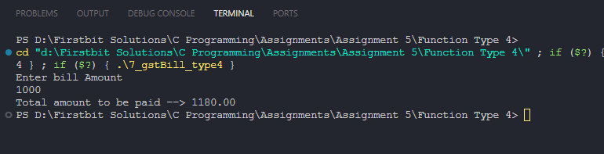

Q)Driver Criteria

*#include*<stdio.h>

*//age must be greater than 40*

*//d exp > 10*

*//12th marks > 60*

int checkDriverEligibility(int, int, int);

int main(){

    int age,exp,marks;

    printf("Enter Age: ");

    scanf("%d", *&*age);

    printf("Enter Exp: ");

    scanf("%d", *&*exp);

    printf("Enter Marks: ");

    scanf("%d", *&*marks);

*// checkDriverEligibility(age, exp, marks);*

    checkDriverEligibility(age, exp, marks) *?* printf("Driver is Eligible\n") *:* printf("Driver is Not Eligible\n");

    printf("End\n");

*return* 0;

}

int checkDriverEligibility(int age, int exp, int marks){

*// (age >40 && exp > 10 && marks > 60) ? printf("Driver is eligible") :printf("Driver is NOT eligible");*

*if*(age *>*40 *&&* exp *>* 10 *&&* marks *>* 60){

*return* 1;

    }

*return* 0;

}

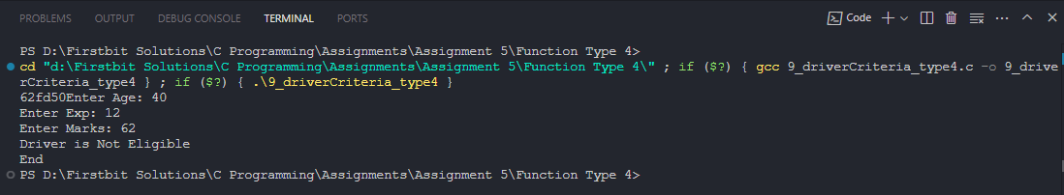

Q)Price after discount

*#include*<stdio.h>

int calNetPrice(int, int);

int main(){

    int price, discount;

    printf("Enter price:\n");

    scanf("%d", *&*price);

    printf("Enter discount percentage Example: 20\n");

    scanf("%d", *&*discount);

    printf("Your net price to be paid is:  %d\n", calNetPrice(price, discount));

*// calNetPrice(price, discount);*

    printf("End\n");

*return* 0;

}

int calNetPrice(int price, int discount){

*// printf("Your net price to be paid is:  %d\n", price - ((price*discount)/100));*

*return* price *-* (price*\**discount)*/*100;

}

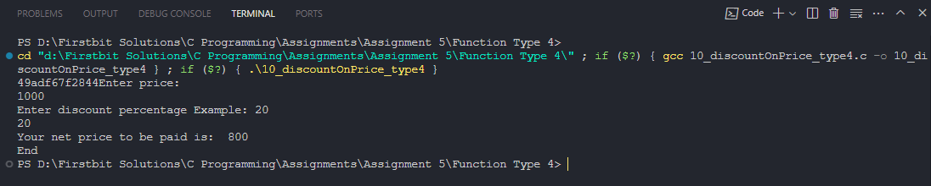

Q)Find greatest of 3 numbers using nested if

*#include*<stdio.h>

int findGreatest(int, int, int);

int main(){

    printf("Start\n");

    int a,b,c;

    printf("Enter the value of a: ");

    scanf("%d",*&*a);

    printf("Enter the value of b: ");

    scanf("%d",*&*b);

    printf("Enter the value of c: ");

    scanf("%d",*&*c);

*// findGreatest(a,b,c);*

    printf("%d is greatest\n",findGreatest(a,b,c));

    printf("End\n");

*return* 0;

}

int findGreatest(int a, int b,int c){

*// int greatest;*

*if*(a*>*b){

*if* (a*>*c)

        {

*// printf("A is Greatest of three.\n");*

*// greatest = a;*

*return* a;

        }

*else*

        {

*// printf("C is Greatest of three.\n");*

*// greatest = c;*

*return* c;

        }

    } *else* {

*if*(b*>*c){

*// printf("B is Greatest of three.\n");*

*return* b;

*// greatest = b;*

        }

*else* {

*// printf("C is Greatest of three.\n");*

*return* c;

*// greatest = c;*

        }

    }

*// printf("%d is Greatest of three.\n", greatest);*

}

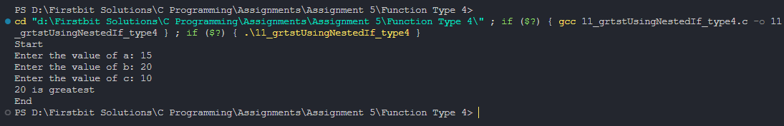

Q) Accept two numbers from user and an operator (+,-,/,*,%) based on that perform the desired operations.

*#include* <stdio.h>

*// for type 2, there ain't return type, so we can not send any value to function for process, so again we have to take input again and again, doesn't make sense, it'll increase repeatation*

int showChoices(int, int ,char);

int main()

{

    printf("Start\n");

    int num1, num2;

    char operator;

    printf("Enter the value of number 1: ");

    scanf("%d", *&*num1);

    printf("Enter the value of number 2: ");

    scanf("%d", *&*num2);

    printf("------Enter your choice :------\n");

    printf("For Addition enter '+'\n");

    printf("For Subtraction enter '-'\n");

    printf("For Multiplication enter '*'\n");

    printf("For Divivsion enter '/'\n");

    printf("For Modulo enter '*%*'\n");

    fflush(stdin);

    scanf("%c", *&*operator);

*// showChoices(num1, num2, operator);*

    printf("%d %c %d = %d\n",num1, operator, num2, showChoices(num1, num2, operator));

    printf("End\n");

*return* 0;

}

int showChoices(int num1, int num2, char operator){

*if* (operator*==* '+')

    {

*// printf("%d %c %d = %d\n", num1, operator, num2, num1 + num2);*

*return* num1*+*num2;

    }

*else* *if* (operator*==* '-')

    {

*// printf("%d %c %d = %d\n", num1, operator, num2, num1 - num2);*

*return* num1*-*num2;

    }

*else* *if* (operator*==* '*')

    {

*// printf("%d %c %d = %d\n", num1, operator, num2, num1 * num2);*

*return* num1*\**num2;

    }

*else* *if* (operator*==* '/')

    {

*// printf("%d %c %d = %d\n", num1, operator, num2, num1 / num2);*

*return* num1 */* num2;

    }

*else* *if* (operator*==* '%')

    {

*// printf("%d %c %d = %d\n", num1, operator, num2, num1 % num2);*

*return* num1 *%* num2;

    }

}

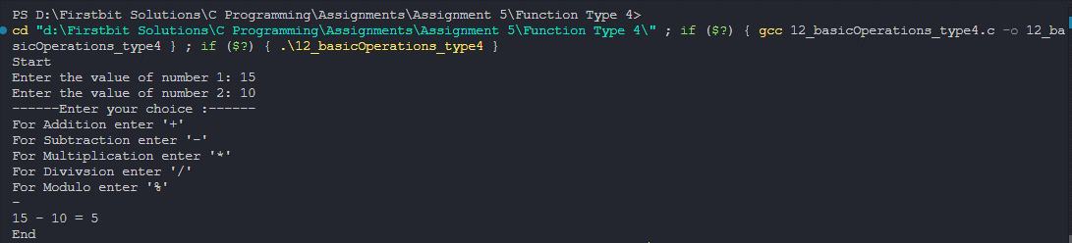

Q) Display a menu to the user (like 1.Even Odd 2. Basic salary etc), ask the user to enter his choice, then based on that perform the desired operations.

*#include* <stdio.h>

int checkEvenOdd(int);

float calculateSalary(float);

int main()

{

    int choiceNum;

    printf("----Choices-----\n");

    printf("Enter 1 for calculate Even odd\n");

    printf("Enter 2 for calculate Salary\n");

    scanf("%d", *&*choiceNum);

*if* (choiceNum *==* 1)

    {

        int num;

        printf("Enter number to check weather number is even or odd.\n");

        scanf("%d", *&*num);

*// checkEvenOdd(num);*

        checkEvenOdd(num) *?* printf("EVEN number\n") *:* printf("ODD number\n");

    }

*else* *if* (choiceNum *==* 2)

    {

        float basic;

        printf("Enter Basic salary\n");

        scanf("%f", *&*basic);

*// calculateSalary(basic);*

        printf("Salary is %.2f\n",calculateSalary(basic));

    }

*else*

    {

        printf("Invalid Choice\n");

    }

*return* 0;

}

int checkEvenOdd(int num)

{

*// num % 2 ? printf("%d is Odd Number\n", num) : printf("%d is Even number\n", num);*

*return* *!*num*%*2;

}

float calculateSalary(float basic)

{

    float salary;

*if* (basic *<=* 5000)

    {

        salary *=* basic *+* (basic *\** 10) */* 100 *+* (basic *\** 20) */* 100 *+* (basic *\** 30) */* 100;

    }

*else*

        salary *=* basic *+* (basic *\** 15) */* 100 *+* (basic *\** 25) */* 100 *+* (basic *\** 30) */* 100;

*// printf("Salary is %.2f\n", salary);*

*return* salary;

}

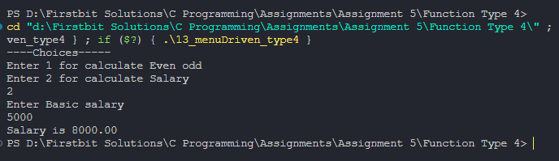

Q) Accept the price from user. Ask the user if he is a student (user may say yes or no). If he is a student and he has purchased more than 500 than discount is 20% otherwise discount is 10%. But if he is not a student then if he has purchased more than 600 discount is 15% otherwise there is not discount.

*#include* <stdio.h>

int checkIsStudent(char);

int main()

{

    printf("Start\n");

    float price;

    int discount;

    printf("\nEnter price: ");

    scanf("%f", *&*price);

    char checkStudent;

    printf("If your are student than press 'Y', else press 'N'\n");

    fflush(stdin);

    scanf("%c", *&*checkStudent);

*// check validation*

*if* (checkIsStudent(checkStudent))

    {

        discount *=* price *>* 500 *?* 20 *:* 10;

    }

*else*

    {

        discount *=* price *>* 600 *?* 15 *:* 0;

    }

*// checkIsStudent(checkStudent, price);*

    printf("You got %d*\%* Discount\n", discount);

    printf("You have to pay %.2f rs.\n", price *-* (price *\** discount) */* 100);

    printf("End\n");

*return* 0;

}

int checkIsStudent(char checkStudent)

{

*// int discount;*

*if* (checkStudent *==* 'y' *||* checkStudent *==* 'Y')

    {

*// discount = price > 500 ? 20 : 10;*

*return* 1;

    }

*else* *if* (checkStudent *==* 'n' *||* checkStudent *==* 'N')

    {

*// discount = price > 600 ? 15 : 0;*

*return* 0;

    }

    printf("Invalid choice for student elligibility\n");

*return* 0;

}

Q)print 1 to 10

*#include*<stdio.h>

*/\**

*--------#########---------*

*NO Change in code at all compare to type 1 function, as there nothing to return and no parameter, we are printing only.*

*--------#########------------*

*\*/*

int print1To10();

int main(){

    printf("Start\n");

    print1To10();

    printf("End\n");

*return* 0;

}

int print1To10(){

*// int i=1;*

*// while(i<11){*

*//     printf("%d\n", i);*

*//     i++;*

*// }*

*for* (int i *=* 1; i *<* 11; i*++*)

    {

        printf("%d\n", i);

    }

*return* 0;

}

Q) Print table for the given number.

*#include* <stdio.h>

int printTable(int, int);

*//Here if we want to return only multiplication, then stack will open and close for 10 times, which takes more time to process*

int main()

{

    printf("Start\n");

    int n;

    printf("Enter Any Number u want to print table of\n");

    scanf("%d", *&*n);

*for* (int i *=* 1; i *<=* 10; i*++*)

    {

        printf("%d x %d = %d\n", n, i, printTable(n, i));

    }

    printf("End\n");

*return* 0;

}

int printTable(int n, int i) {

*return* n*\**i;

}

Q)Sum of nums in given range

*#include*<stdio.h>

int sumInRange(int, int);

int main(){

    int lower, upper;

    printf("Enter Lower limit and Upper limit of Range\n");

    scanf("%d %d", *&*lower, *&*upper);

    printf("Sum of Num from %d to %d is %d", lower, upper, sumInRange(lower, upper));

*return* 0;

}

int sumInRange(int lower, int upper){

    int sum*=*0;

*for* (int i *=* lower; i *<=* upper; i*++*)

    {

        sum *+=* i;

    }

*return* sum;

}

Q)Check Prime number

*#include* <stdio.h>

int checkPrime(int);

int main()

{

    printf("Start\n");

    int num;

    printf("Enter number u want to check prime of\n");

    scanf("%d", *&*num);

*// checkPrime(num);*

    checkPrime(num) *?* printf("Num is Prime Number\n")*:* printf("Num is NOT a Prime Number\n");

    printf("End\n");

*return* 0;

}

int checkPrime(int num){

*for* (int i *=* 2; i*\**i *<=* num; i*++*)

    {

*if* (num *%* i *==* 0)

        {

*return* 0;

        }

    }

*return* 1;

}

Q)Check Prime Number

*#include* <stdio.h>

int checkPrime(int);

int main()

{

    printf("Start\n");

    int num;

    printf("Enter number u want to check prime of\n");

    scanf("%d", *&*num);

*// checkPrime(num);*

    checkPrime(num) *?* printf("Num is Prime Number\n")*:* printf("Num is NOT a Prime Number\n");

    printf("End\n");

*return* 0;

}

int checkPrime(int num){

*for* (int i *=* 2; i*\**i *<=* num; i*++*)

    {

*if* (num *%* i *==* 0)

        {

*return* 0;

        }

    }

*return* 1;

}

Q)Armstrong number

*#include* <stdio.h>

*#include* <math.h>

*// if 123 is num, and 1^3 + 2^3 + 3^3 = 123, then its armstrong num*

*//example 153 = 1 + 125+ 27 is armstrong num*

*//1634 = 1^4 + 6^4 + 3^4 + 4^4*

int checkArmStrong(int);

int main()

{

    printf("Start\n");

    int num;

    printf("Enter a number:\n");

    scanf("%d", *&*num);

*// checkArmStrong(num);*

    checkArmStrong(num) *?* printf("Number is Armstrong\n") *:* printf("Number is Not an Armstrong\n");

    printf("End\n");

*return* 0;

}

int checkArmStrong(int num){

    int temp *=* num, sum *=* 0, count *=*0;

*//find length of number to find exponent*

*while*(temp*>*0){

        count*++*;

        temp */=* 10;

    }

    printf("Count = %d\n", count);

*//temp becomes 0, so ressign for further use*

    temp *=* num;

*while* (temp *>* 0)

    {

        int rem *=* temp *%* 10;

*//cal power of rem*

        int power *=* 1, tempCount *=* count;

*for* (int i *=* 1; i *<=* tempCount; i*++*)

        {

            power *\*=* rem;

        }

*// printf("Power = %d\n", power);*

        sum *+=* power;

        temp */=* 10;

    }

*// sum == num ? printf("Number is Armstrong\n") : printf("Number is Not an Armstrong\n");*

*return* sum *==* num;

}

Q)Perfect Number

*#include*<stdio.h>

*//number can be called perfect if, sum of its divisors is same as number itself*

*//ex: 6 because 1 + 2 + 3 = 6*

*//28 beacuse, 1 +2 + 4 + 7 + 14 =28*

int checkPerfectNum(int);

int main(){

    printf("Start\n");

    int num;

    printf("Enter a num:\n");

    scanf("%d", *&*num);

    checkPerfectNum(num) *?* printf("Num is a Perfect number\n")*:*printf("Num is NOT a Perfect number\n") ;

*// checkPerfectNum(num);*

    printf("End\n");

*return* 0;

}

int checkPerfectNum(int num){

    int temp *=* num, sum *=*0;

*for* (int i *=* 1; i *<=* temp*/*2; i*++*)

    {

*if*(num*%*i*==*0) sum *+=* i;

    }

*return* temp*==*sum;

*// if(temp==sum) printf("%d is a Perfect number\n", num);*

*// else printf("%s is not a Perfect num\n", num);*

}

Q)Find Factorial

*#include*<stdio.h>

int findFactorial(int);

int main(){

    printf("Start\n");

    int num;

    printf("Enter a number:\n");

    scanf("%d", *&*num);

    printf("%d! = %d\n",num, findFactorial(num));

*// findFactorial(num);*

    printf("End\n");

*return* 0;

}

int findFactorial(int num) {

    int temp *=*num, fact *=*1;

*for*(int i*=*num; i*>*0;i*--*){

        fact *\*=* i;

    }

*// printf("%d! = %d\n",temp, fact);*

*return* fact;

}

Q)Strong Num

*#include* <stdio.h>

*// num is called strong if its sum of its digit's factorial is same as num*

*// ex: 145, 1! + 4!+ 5! = 145*

int checkStrongNum();

int main()

{

    printf("Start\n");

    int num;

    printf("Enter a number:\n");

    scanf("%d", *&*num);

    checkStrongNum(num) *?* printf("Num is Strong Num\n") *:* printf("Num is NOT a Strong Num\n");

*// checkStrongNum(num);*

    printf("End\n");

*return* 0;

}

int checkStrongNum(int num) {

    int temp *=* num, rem, sum *=* 0;

*while* (temp *>* 0)

    {

        rem *=* temp *%* 10;

*//--------Factorial Calculation-------*

*// find factorial of rem*

        int factorial *=* 1;

*while* (rem *>* 0)

        {

            factorial *\*=* rem;

            rem*--*;

        }

*// add factorial of rem to sum*

        sum *+=* factorial;

*// continue*

        temp */=* 10;

    }

*return* sum*==*num;

}

Q)Check Palindrome

*#include* <stdio.h>

*// 121, 1331, 12321*

int checkPalindrome(int);

int main()

{

    printf("Start\n");

    int num;

    printf("Enter a number:\n");

    scanf("%d", *&*num);

    checkPalindrome(num) *?* printf("Num is Palindrome\n") *:* printf("Num is NOT Palindrome\n");

*// checkPalindrome(num);*

    printf("End\n");

*return* 0;

}

int checkPalindrome(int num) {

    int temp *=* num, rem, rev *=* 0;

*while* (temp *>* 0)

    {

        rem *=* temp *%* 10;

        rev *=* rev *\** 10 *+* rem;

        temp */=* 10;

    }

*return* num*==*rev;

}

Q)Sumation of first digit and last digit

*#include*<stdio.h>

*#include*<math.h>

*//add first and and last digit of given num*

int findFirstNLastDigSum(int);

int main(){

    printf("Start\n");

    int num;

    printf("Enter a number:\n");

    scanf("%d", *&*num);

    printf("Sum of first digit and last digit of number is %d\n", findFirstNLastDigSum(num));

*// findFirstNLastDigSum(num);*

    printf("End\n");

*return* 0;

}

int findFirstNLastDigSum(int num){

    int temp *=* num, lastDigit, firstDigit, lengthOfNum*=*0;

    lastDigit *=* temp*%*10;

*//logic 2 for find 1st digit of num*

*while* (temp*>*0)

    {

        firstDigit *=* temp*%*10;

        temp */=* 10;

    }

*return* firstDigit *+* lastDigit;

}